FOR IMMEDIATE RELEASE:
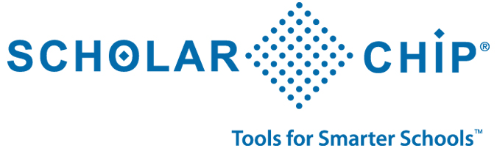
ScholarChip® Awarded Contract to provide SMART PHOTO id-CARDS TO StudentS and STAFF IN South Carolina’s sixth largest School district
New York, NY | Dec. 10, 2013 – ScholarChip® is pleased to announce that Richland County School District One has become a partner school district. As the awarded firm, ScholarChip will provide the District with twenty smart ID-card issuance stations.
Through a secure integration with their Student Information System, Richland One will now issue contactless smart cards to both students and staff. ScholarChip’s card features NFC (Near Field Communication) technology and operates seamlessly with mobile Android tablets and phones. The new ID cards will act as baseline for future automation associated with the District’s safety and operations. Richland One will begin by using ScholarChip’s student mobile Hall Monitoring service: displaying a student photo, demographics and schedules with the tap of their contactless ID.
As a large county-wide school district, Richland One recognized the need for an innately scalable solution. ScholarChip presented the District with an enterprise option that was easily configurable to match their requirements.
As the Technology Application Support Coordinator for Richland One County School District, Ms. Cindy Ferjani describes a smooth implementation.
“The implementation went rather quickly,” Ferjani said. “The feedback that I have received from our staff is that the system is very user-friendly and that the Help Desk is wonderful.”
ScholarChip is a New York-based technology firm providing K-12 schools with a comprehensive School Safety and Operation System (SSOS). By issuing smart ID-cards, Richland One has positioned itself to move—as need and budget dictate—towards automated attendance, campus safety and operations. Administrators now have the potential to manage multiple school services from a single secure login to ScholarChip’s central web portal.
“We were impressed with the company and the multiple uses they provided with a single badge and look forward to utilizing it to improve business efficiencies in the district," Ferjani said.
About ScholarChip
ScholarChip Card LLC is a leading provider of advanced applications for the educational community. ScholarChip pioneered the concept of a centralized and integrated K-12 School Safety and Operations System. ScholarChip's services extend to the Higher Education market, providing high speed Tuition Payment Plans, Loan Servicing and a compliant Payment Gateway.

